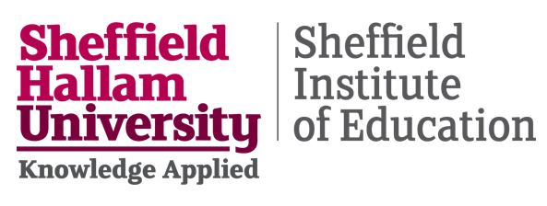
Collaboration Agreement - Adapt-Ed: Climate Adaptation through Education
Parties
This agreement is between:
- Sheffield Hallam University (Lead organisation)
- Participating school
Purpose
This agreement outlines the roles, responsibilities, and expectations for collaboration between Sheffield Hallam University and the participating school in delivering the Adapt-Ed project.
The project aims to:
- Build teacher capacity in climate adaptation education
- Engage pupils in place-based learning
- Generate evidence on educational and behavioural impacts

Roles and responsibilities
Sheffield Hallam University will:
- Lead project coordination, research, and evaluation
- Provide curriculum resources and CPD
- Ensure ethical approval and compliance for research activities
The school will:
- Support participation of staff and pupils
- Facilitate access for agreed activities
- Ensure a staff member is present during pupil sessions
- Follow school policies on safeguarding and parental communication
Delivery partners
Activities may also be delivered by:
- The Green Estate
- Sheffield City Council
All partners will operate under Sheffield Hallam University ethical approval and safeguarding expectations. Delivery partners may support data collection but will not retain research data; all data will be transferred securely to Sheffield Hallam University
Data and confidentiality
Sheffield Hallam University will manage all research data in line with data protection legislation and research ethics requirements.
All data used for analysis and reporting will be anonymised and reported at an aggregate level.
Any data shared with external partners will:
- be anonymised or pseudonymised as appropriate
- exclude identifiable pupil information
- be transferred using secure, approved systems

All data sharing will be subject to participant consent and ethical approval. Data will be used for research and evaluation purposes only and will not be used for commercial purposes. Fully anonymised data may be processed using secure, university-approved AI tools to support analysis. No identifiable or pseudonymised data will be used in this way.

Safeguarding
All activity will:
- Take place during school hours or agreed sessions
- Follow school safeguarding procedures
- Be delivered by appropriately trained and DBS-checked staff

Working in partnership
The project is designed as a collaborative partnership between Sheffield Hallam University, the school, and delivery partners. Schools will have opportunities to contribute to the development of activities and reflect on outcomes.
Duration
This agreement covers the period:
March 2026 – November 2026
Withdrawal
The school may withdraw from participation at any time without penalty.
Agreement
School name: ______________________________________________
Headteacher / authorised signatory: __________________________
Signature: __________________________________________________
Date: _______________________________________________________
(Required to participate in the project)

